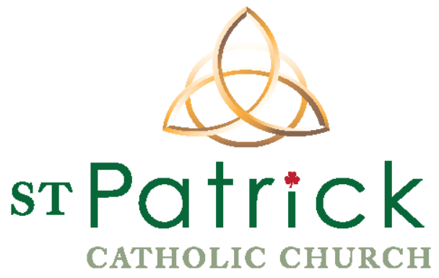
The Mission of St. Patrick's Catholic Community is to proclaim and live the Gospel message of unconditional love, healing and reconciliation through prayer, celebration and action on behalf of justice as a sign of hope for all God's people.
Welcome to St. Patrick’s Parish

Name: __________________________________________ Cell Phone: _______________________
Last First

Email: ____________________________________________________________________________

Address: ____________________________________________________________________________
Street Address Apt #

____________________________________________________________________________
City State Zip

Which Sunday Mass do you normally attend? 8:30 11:00 5:15
Would you like to be considered a registered member of the parish? Yes No
Would you like to receive a set of boxed offertory envelopes? Yes No

Please Tell Us About Your Household Members
Name  (Include last name if it is different than yours) | Nickname | Gender | Relationship | Birth Date | Sacraments  Received | Occupation  Or Grade if Student
YOU |  |  | Self | ___/____/___ | Baptism  1st Eucharist  Reconciliation  Confirmation
Name: |  |  |  | ____/____/____ | Baptism  1st Eucharist  Reconciliation  Confirmation
Email Address: |  | Cell Phone:  ( ) - |  | Interests:
Name: |  |  |  | ____/____/____ | Baptism  1st Eucharist  Reconciliation  Confirmation
Name: |  |  |  | ____/____/____ | Baptism  1st Eucharist  Reconciliation  Confirmation

Signature ___________________________________________________ Date _____________________

